**Rafting Site – Planning Document**

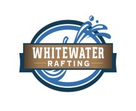

Choice Colors

* primary-color #505033
* secondary-color: #264969
* accent1-color: #CFCFB4
* accent2-color: #B4CDE4

Choice Fonts

* heading-font: Georgia, sans-serif
* text-font: Roboto", sans-serif

Color Pallette

https://coolors.co/505033-264969-cfcfb4-b4cde4